CYCLE-3
PART-A
Mathplotlib
Demonstrate creating various types of charts and plots using functions in mathplotlib library

- Sarah bought a new car in 2001 for $24,000. The dollar value of her car changed each year as shown in the table below.
Value of Sarah's Car
Year Value
2001 $24,000
2002 $22,500
2003 $19,700
2004 $17,500
2005 $14,500
2006 $10,000
2007 $ 5,800
Represent the following information using a line graph with following style properties
- X- axis - Year
Y –axis - Car Value
- title –Value Depreciation (left Aligned)
- Line Style dashdot and Line-color should be red
- point using * symbol with green color and size 20
Subplot() provides multiple plots in one figure.
PROGRAM
import matplotlib.pyplot as plt
import numpy as np
xpoints = np.array([2001, 2002,2003,2004,2005,2006,2007])
ypoints = np.array([24000, 22500,19700,17500,14500,10000,5800])
plt.plot(xpoints, ypoints, '*g',ms = 20)
plt.plot(xpoints, ypoints, ':r')
leg = plt.legend(title="Value Depreciation ")
leg._legend_box.align = "left"
plt.show()
OUTPUT
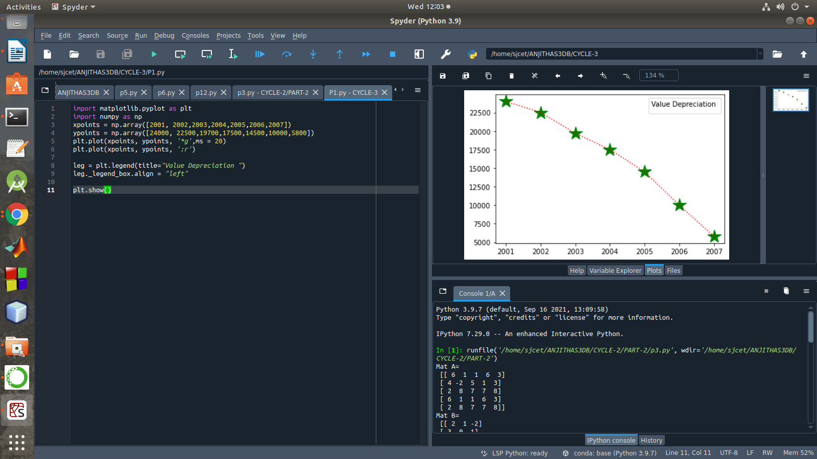

- Following table gives the daily sales of the following items in a shop
Day | Mon | Tues | Wed | Thurs | Fri
Drinks | 300 | 450 | 150 | 400 | 650
Food | 400 | 500 | 350 | 300 | 500

Use subplot function to draw the line graphs with grids(color as blue and line style dotted) for the above information as 2 separate graphs in two rows
- Properties for the Graph 1:
- X label- Days of week
- Y label-Sale of Drinks
- Title-Sales Data1 (right aligned)
- Line –dotted with cyan color
- Points- hexagon shape with color magenta and outline black

- Properties for the Graph 2:
- X label- Days of Week
- Y label-Sale of Food
- Title-Sales Data2 ( center aligned)
- Line –dashed with yellow color
- Points- diamond shape with color green and outline red
PROGRAM
import matplotlib.pyplot as plt
import numpy as np
#plot 1:
x = np.array(['mon', 'tue', 'wed', 'thur','fri'])
y = np.array([300, 450, 150, 400,65])
plt.subplot(1, 2, 1)
plt.title("Sales Data1")
plt.xlabel("Days of week")
plt.ylabel("Sale of Drinks")
plt.plot(x,y,':c')
plt.plot(x,y,'Hm',mec = 'k')
plt.grid(color = 'blue', linestyle = 'dotted')
#plot 2:
c = np.array(['mon', 'tue', 'wed', 'thur','fri'])
v = np.array([400, 500, 350, 300,500])
plt.subplot(1, 2, 2)
plt.title("Sales Data2")
plt.xlabel("Days of Week")
plt.ylabel("Sale of Food")
plt.plot(c,v,'--y')
plt.plot(c,v,'Dg',mec = 'r')
plt.grid(color = 'blue', linestyle = 'dotted')
plt.show()
OUTPUT

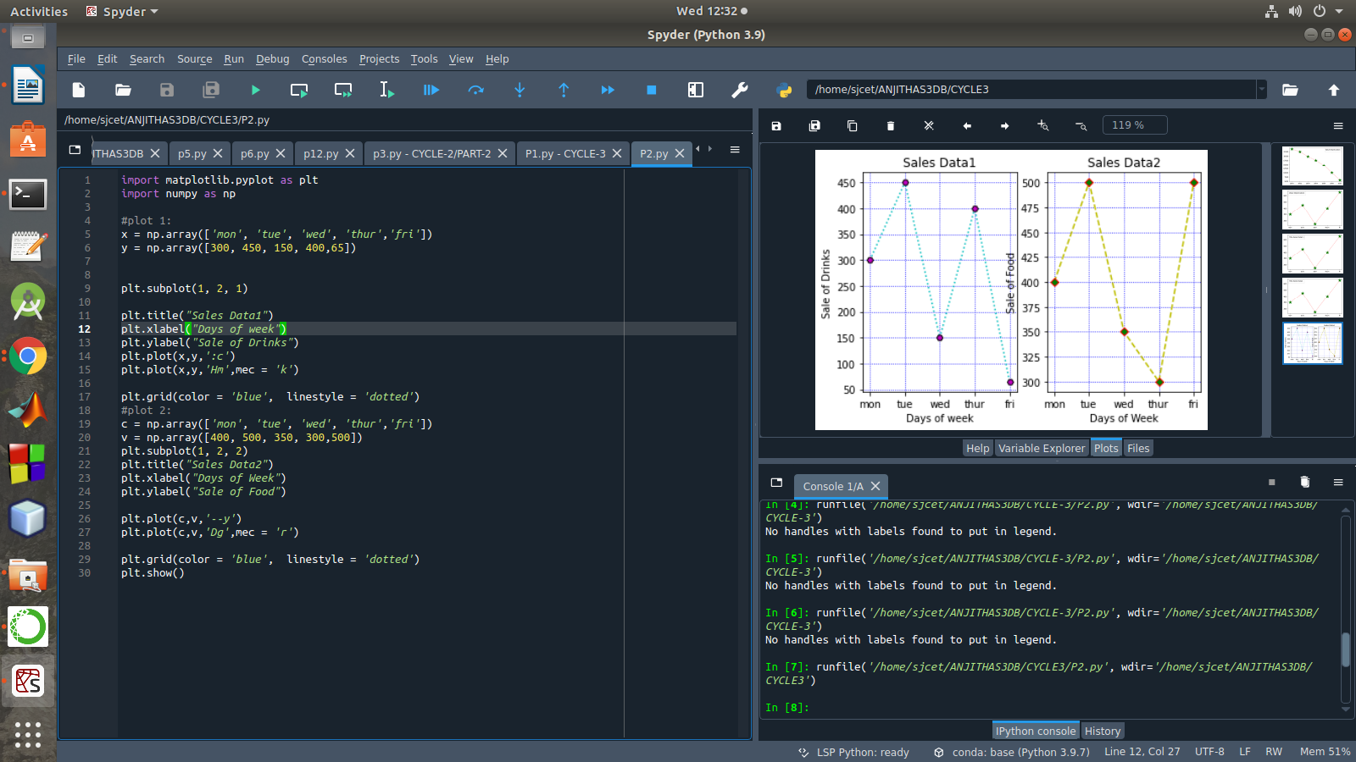

- Create scatter plot for the below data:(use Scatter function)
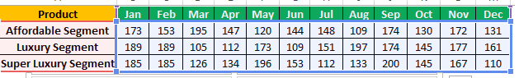

Create scatter plot for each Segment with following properties within one graph
- X Label- Months of Year with font size 18
- Y-Label- Sales of Segments
- Title –Sales Data
- Color for Affordable segment- pink
- Color for Luxury Segment- Yellow
- Color for Super luxury segment-blue
PROGRAM
import matplotlib.pyplot as plt
import numpy as np
plt.title("Sales Data")
plt.xlabel("Months of Year"size=18)
plt.ylabel("Sale of Food")
x = np.array(['Jan','Feb','Mar','Apr','May','Jun','Jul','Aug','Sep','Oct','Nov','Dec'])
y1 = np.array([173,153,195,147,120,144,148,109,174,130,172,131])
plt.scatter(x,y1, color = 'hotpink')
y2 = np.array([185,185,126,134,196,153,112,133,200,145,167,110])
plt.scatter(x, y2, color = 'yellow')
y3 = np.array([189,189,105,112,173,109,151,197,174,145,177,161])
plt.scatter(x, y3, color = 'blue')
plt.show()
OUTPUT
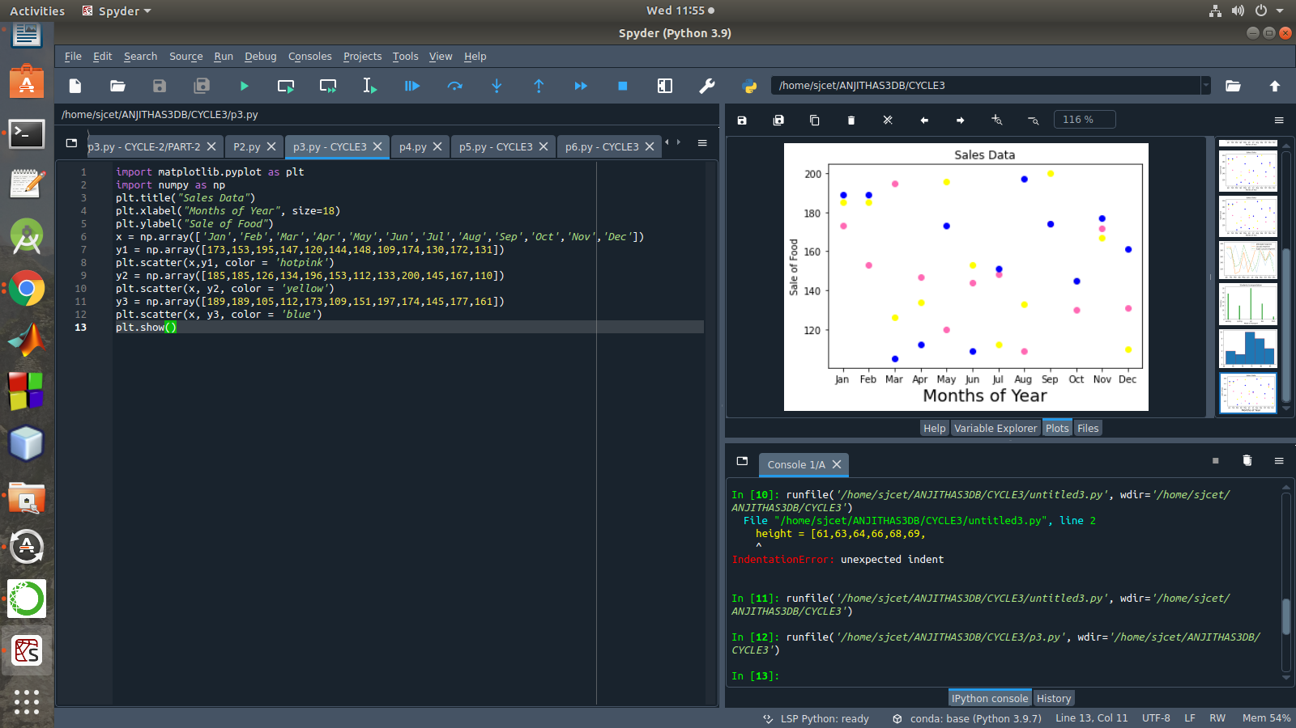

- Display the above data using multiline plot( 3 different lines in same graph)
- Display the description of the graph in upper right corner(use legend())
- Use different colors and line styles for 3 different lines
PROGRAM
import matplotlib.pyplot as plt
import numpy as np
x = np.array(['Jan','Feb','Mar','Apr','May','Jun','Jul','Aug','Sep','Oct','Nov','Dec'])
y1 = np.array([173,153,195,147,120,144,148,109,174,130,172,131])
y2= np.array([189,189,105,112,173,109,151,197,174,145,177,161])
y3= np.array([185,185,126,134,196,153,112,133,200,145,167,110])
plt.plot(x,y1,label = "Affordable Segment",ls=':')
plt.plot(x,y2,label = "Luxuary Segment",ls="-")
plt.plot(x,y3,label = "Super Luxuary Segment",ls="-.")
plt.legend()
plt.show()

OUTPUT
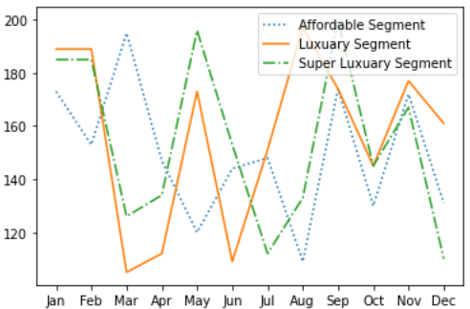

- 100 students were asked what their primary mode of transport for getting to school was. The results of this survey are recorded in the table below. Construct a bar graph representing this information.

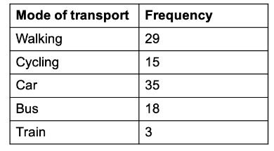
Create a bar graph with
- X axis -mode of Transport and Y axis ‘frequency’
- Provide appropriate labels and title
- Width .1, color green
PROGRAM
import matplotlib.pyplot as plt
import numpy as np
plt.title("Students transportation")
plt.xlabel("Mode of Transport")
plt.ylabel("Frequency")
x = np.array(["walking","cycling","car","bus","train"])
y = np.array([29,15,35,18,3])
plt.bar(x, y, color = "#4CAF50",width = 0.1)
plt.show()
OUTPUT
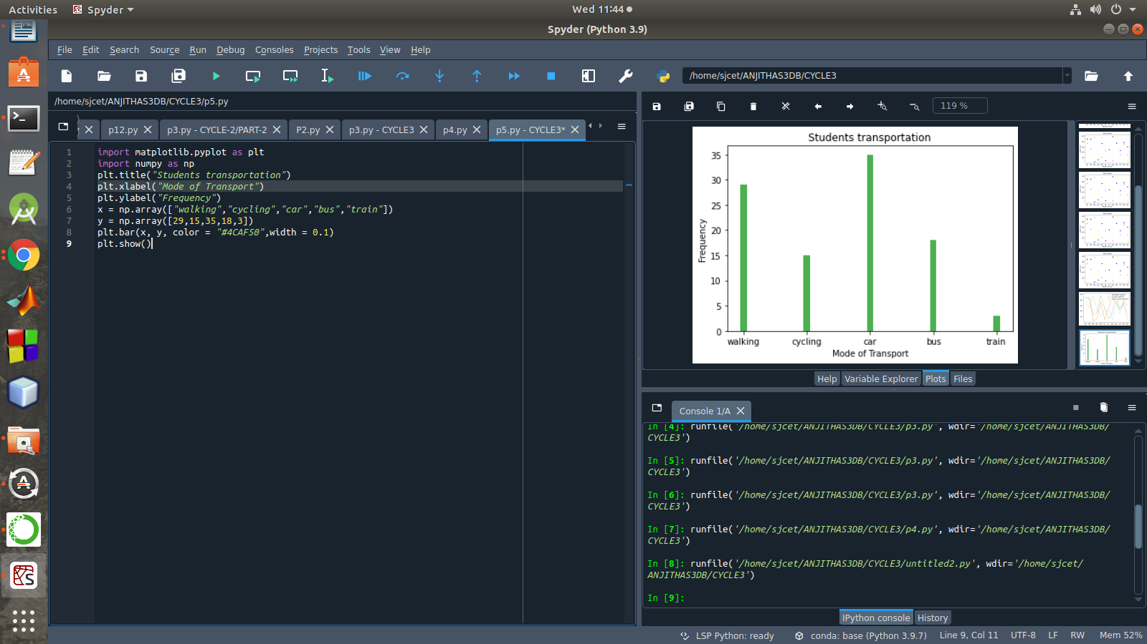

- We are provided with the height of 30 cherry trees.
The height of the trees (in inches): 61, 63, 64, 66, 68, 69, 71, 71.5, 72, 72.5, 73, 73.5, 74, 74.5, 76, 76.2, 76.5, 77, 77.5, 78, 78.5, 79, 79.2, 80, 81, 82, 83, 84, 85, 87.Create a histogram with a bin size of 5
PROGRAM
import matplotlib.pyplot as plt
height = [61,63,64,66,68,69,
71,71.5,72,72.5,73,73.5,74,74.5,76,76.2,76.5,77,77.5,78,78.5,79,79.2,80,81,82,83,84,85,87
]
plt.hist(height, edgecolor="red", bins=5)
plt.show()
OUTPUT
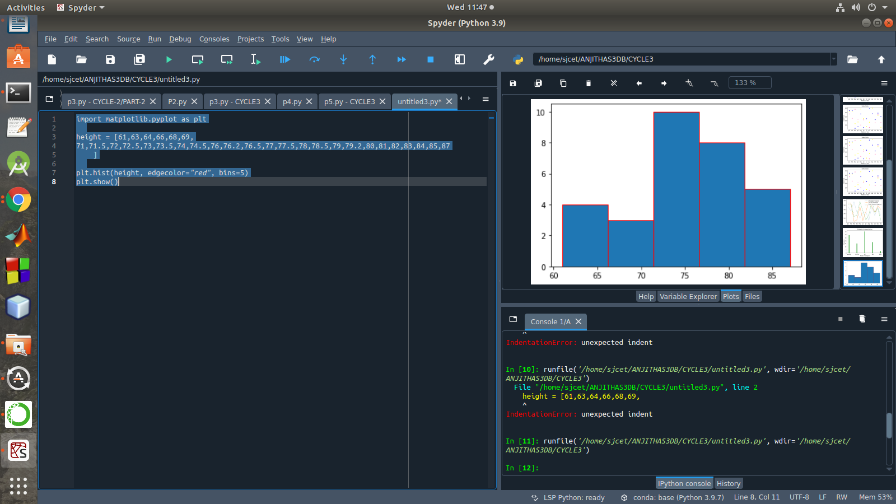

PART-B
1. Use appropriate functions in pandas to display

- Shape of the data set
- First 5 and last five rows of data set(head and tail)
- Size of dataset
- No:of samples available for each variety
- Description of the data set( use describe

PROGRAM
import numpy as np
import matplotlib.pyplot as plt
import seaborn as sns
import pandas as pd
col=['sepal_length','sepal_width','petal_length','petal_width','type']
iris=pd.read_csv("iris.csv",names=col)
print("First five rows")
print(iris.head())
print("*********")
print("columns",iris.columns)
print("*********")
print("shape:",iris.shape)
print("*********")
print("Size:",iris.size)
print("*********")
print("no of samples available for each type")
print(iris["type"].value_counts())
print("*********")
print(iris.describe())

OUTPUT
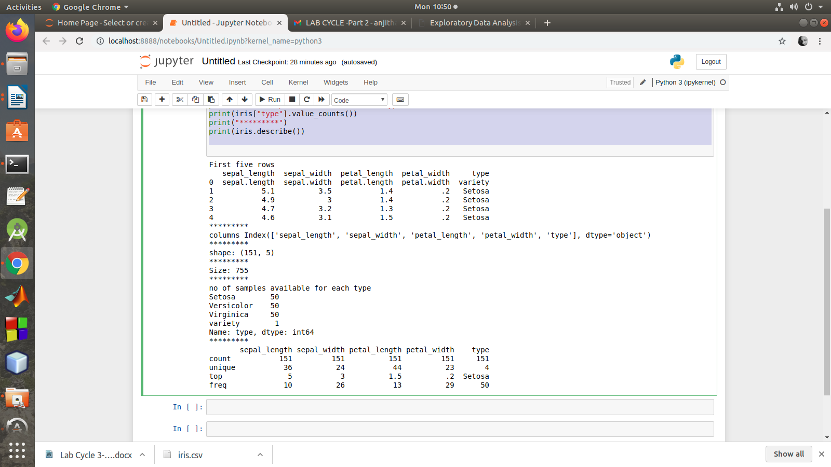

2.Use pairplot() function to display pairwise relationships between attributes. Try different kind of plots {‘scatter’, ‘kde’, ‘hist’, ‘reg’} and different kind of markers
PROGRAM
import numpy as np
import pandas as pd
import seaborn as sns

import matplotlib.pyplot as plt
%matplotlib inline

iris = sns.load_dataset('iris')
my_data_frame = pd.DataFrame(iris)

g = sns.pairplot(my_data_frame)
g = sns.pairplot(iris, kind="reg", hue="species")
g = sns.pairplot(iris, kind="hist", hue="species")
g = sns.pairplot(iris, kind="kde", hue="species")
g = sns.pairplot(iris, kind="scatter", hue="species")

OUTPUT
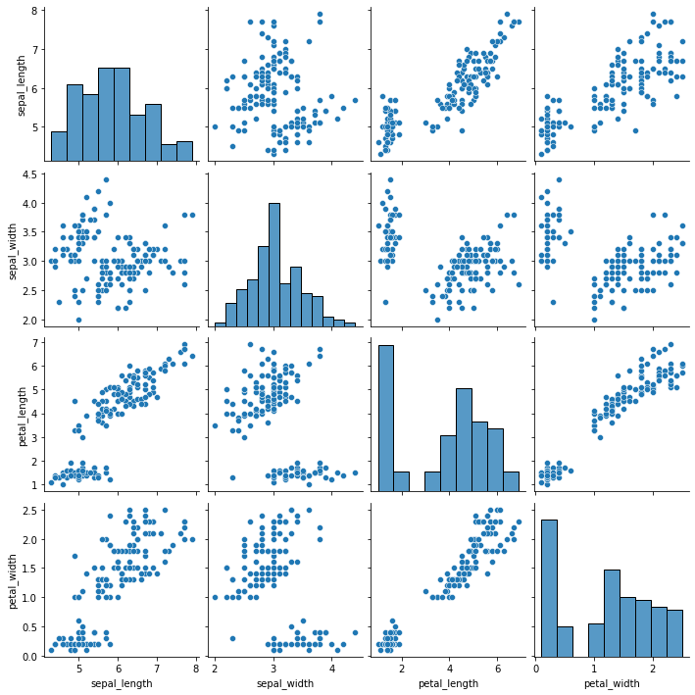

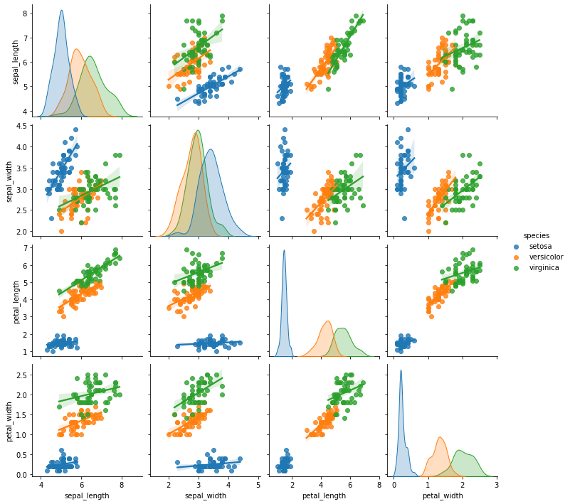

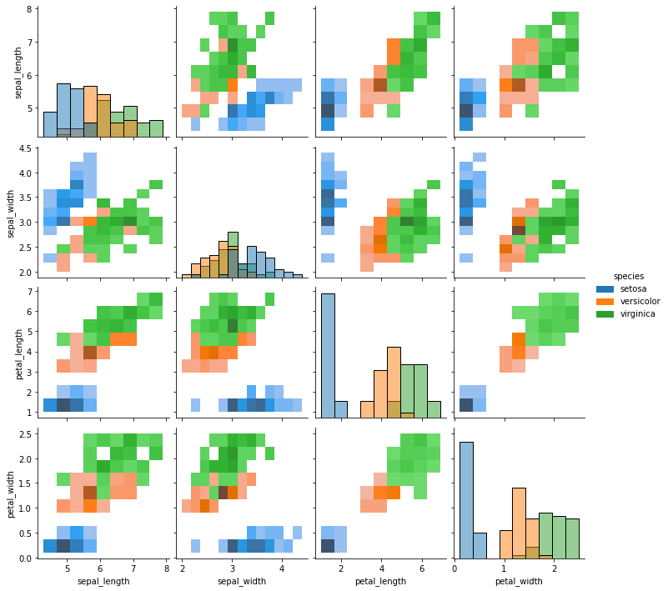
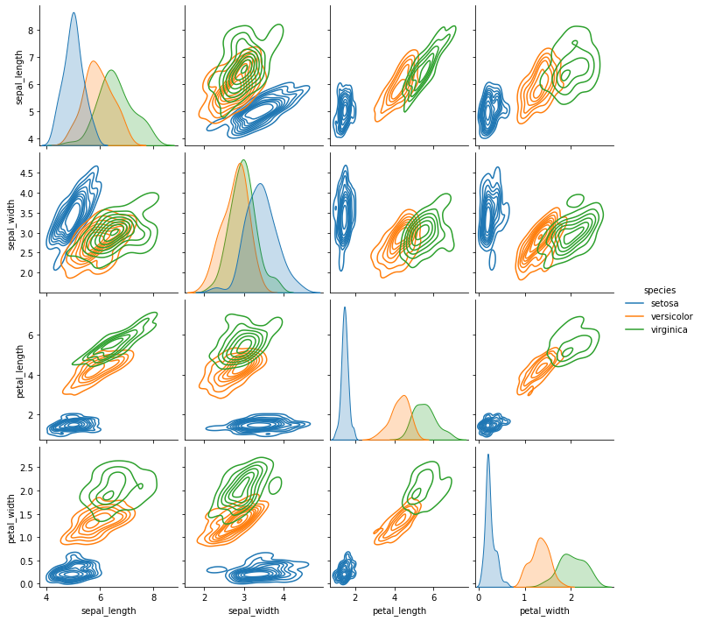

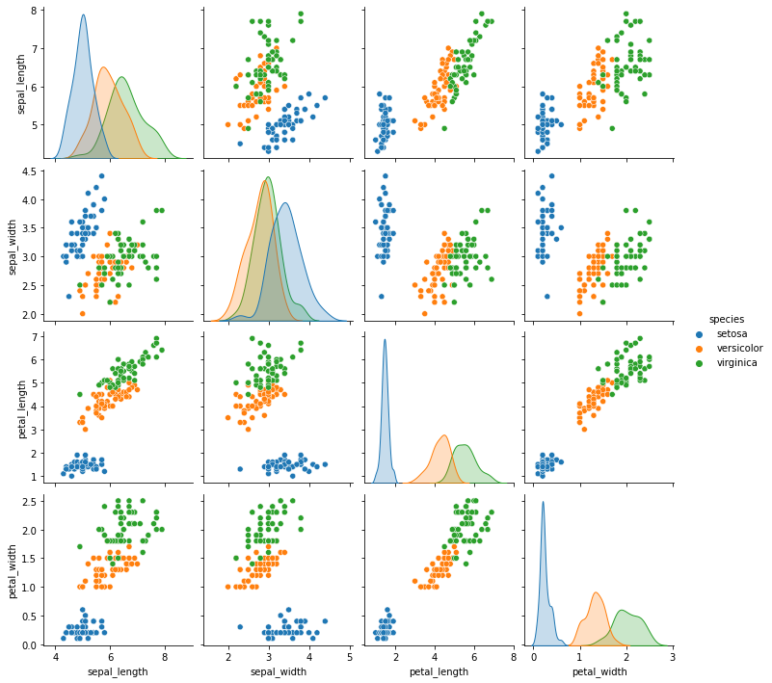
3.using the iris data set,get familiarize with functions:
1)displot()
PROGRAM
import seaborn as sns
import pandas
Import matplotlib.pyplot as plt
sns.get_dataset_names()
df = sns.load_dataset('iris')
df.head()
sns.displot(x = 'sepal_length',kde=True,bins = 5 , data =df)

OUTPUT
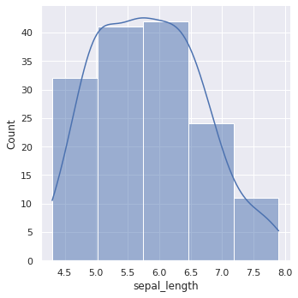

2) histplot()
PROGRAM
import seaborn as sns
import pandas
import matplotlib.pyplot as plt
sns.get_dataset_names()
df = sns.load_dataset('iris')
df.head()
sns.histplot(x = 'sepal_length',kde=True,bins = 6 , data =df)
OUTPUT
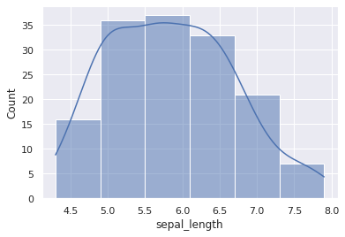

3)relplot()
PROGRAM
import seaborn as sns
sns.set(style ="ticks")
dataset = sns.load_dataset('iris')
col=['sepal_length','sepal_width','petal_length','petal_width','type']
sns.relplot(x ="sepal_length", y ="petal_width", data = dataset)
OUTPUT
